EYFS Term 4 Learning Web 2026

Understanding the World  - Comparing the UK with other countries  - Learning about seasonal changes  - Looking at lifecycles of plants and animals  - Being able to explain how humans change as they get older  - Learning about how we can help look after our environment  - Learning about how Holi and Easter are celebrated and why  - Finding out about how materials change when heated or cooled  - Finding out about the roles different people have in our community | Mathematics  - to recognise attributes of objects eg. tall, long  - to compare amounts of quantities  - to show awareness of comparison in estimating and predicting  - to recognise relationship between size and number  - to begin to use units to compare things  - to begin to use time to sequence events  - to begin to experience specific time durations  - use their fingers to represent 6 as ‘5 and a bit’  - use double dice frames to represent 6 as 5 and 1 more.  - use their fingers to represent 6 as ‘5 and a bit’  - use double dice frames to represent 6 as 5 and 1 more.  - use ‘more than’ and ‘fewer than’ to describe quantities |  | Literacy  - Daily phonics/reading  - Decoding, encoding and blending  - Writing CVC, CVCC words  - Beginning to write captions/short sentences  - Introduced to capital letters, finger spaces and full stops
Cultural capital experiences:  - Visiting parents sharing experiences of living in other countries  - Visiting the library  - Visiting the park  - Spring walks  - World Book Day Celebrations  - Watching the process of caterpillars becoming butterflies | Come outside!  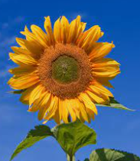 |  | Physical Development  - Daily opportunities to develop gross/fine motor skills  - Use of big bikes  - Apparatus in PE  - PE sessions will be games/gymnastics
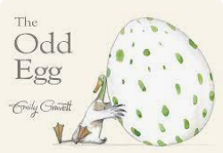  Key texts:  - The Odd Egg  - Hansel and Gretel  - Superworm  - Percy the Park keeper |  | Expressive Arts  - Printing using natural materials  - Observational drawings of plants, animals and flowers  - Building bug hotels in Forest School  - Creating collage  - Self-portraits  - Colour mixing

