EYFS Term 5 Learning Web 2026

Understanding the World  - Children will be able to talk about past events (Neil Armstrong)  - Children will know similarities and differences between in the past and now (Transport)  - Children will know similarities and differences between the natural world around them and contrasting environments (hot and cold countries)  - Children will understand aspects of changing states of matter (cooking)  - Road safety | Mathematics  - continue to develop counting skills,  - counting larger sets as well as counting actions and sounds  - explore a range of representations of numbers, including the 10-frame, and see how doubles can be arranged in a 10-frame  - compare quantities and numbers,including sets of objects which have different attributes  - continue to develop a sense of magnitude, e.g. knowing that 8 is quite a lot more than 2, but 4 is only a little bit more than 2  - begin to generalise about ‘one more than’ and ‘one less than’ numbers within 10  • continue to identify when sets can be subitised and when counting is  necessary  • develop conceptual subitising skills including when using a rekenrek |  | Literacy  - Daily phonics/reading  - Decoding, encoding and blending  - Writing CVC, CVCC words  - Beginning to write captions/short sentences  - Beginning to use capital letters, finger spaces and full stops
Cultural capital experiences:  - Watching the process of caterpillars becoming butterflies  - Pyjamarama  - Tasting foods from around the world  - Boarding a pretend aeroplane  - Trip to Cotswold Wildlife Park  - Visiting the library | Ticket to ride!  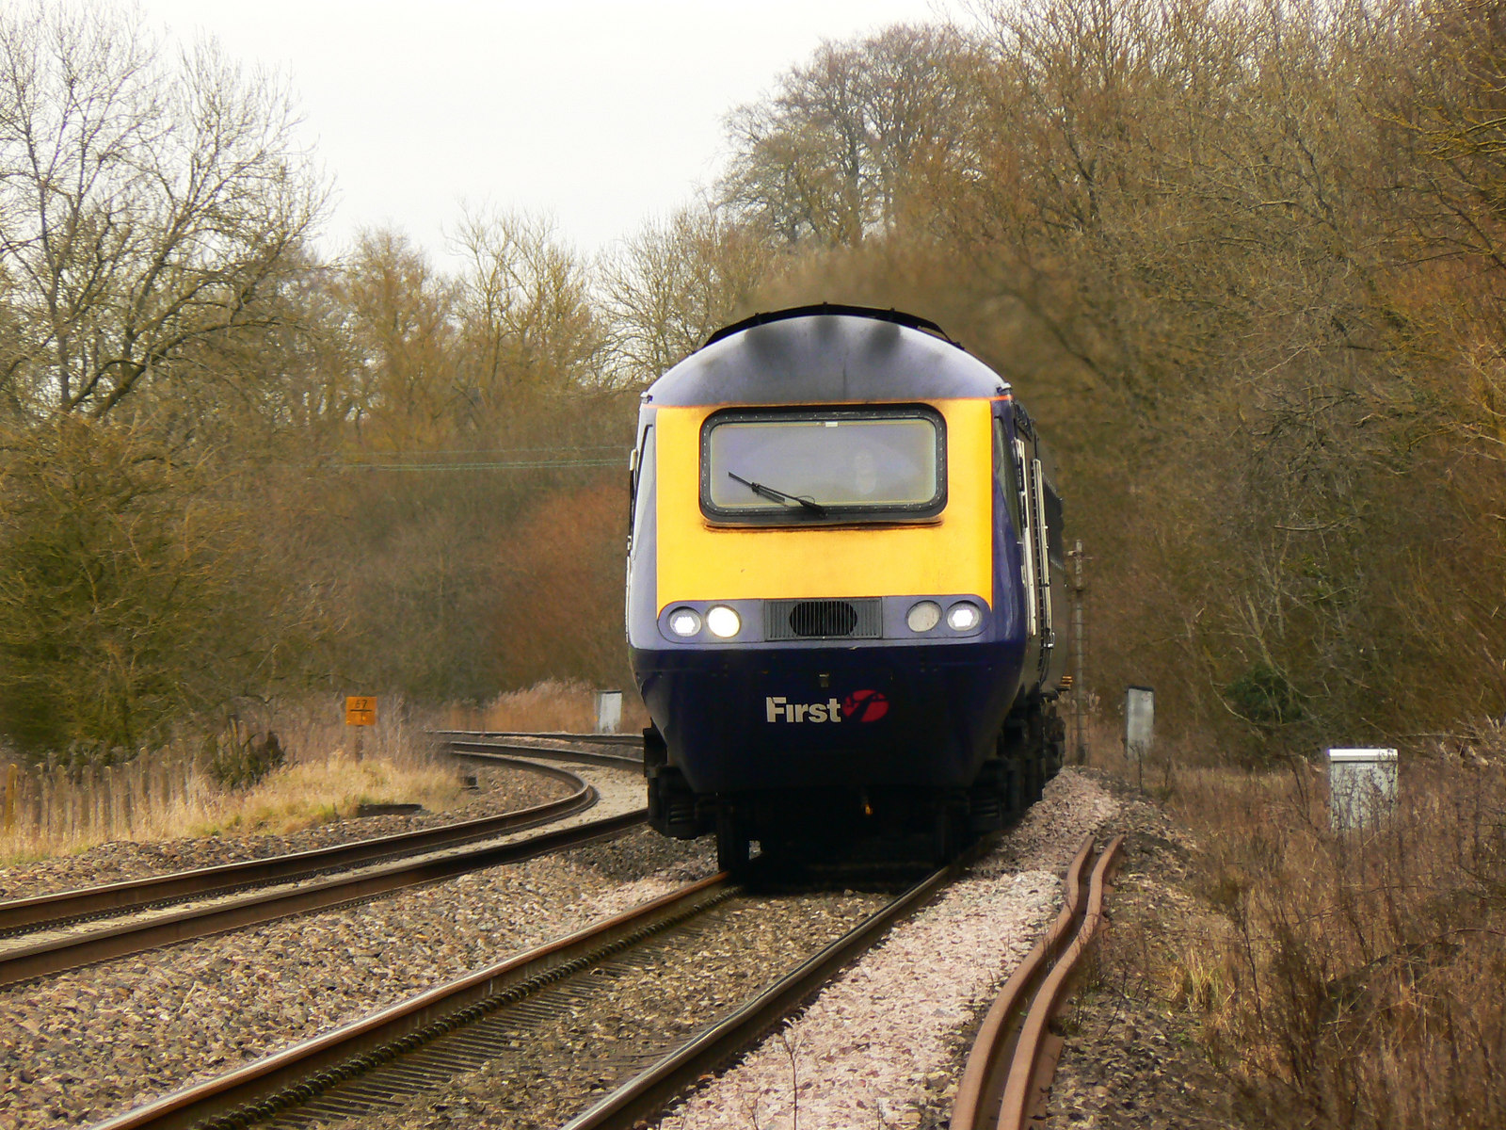 |  | Physical Development  - Daily opportunities to develop gross/fine motor skills  - Use of big bikes  - Apparatus in PE  - PE sessions will be athletics  - swimming
Key texts:  100 decker bus, Penguin, Room on the Broom, The 3 Little Pigs, Pirate Pete, Pink Panther, atlases |  | Expressive Arts  - Printing  - Natural art  - Modelling aliens  - Junk modelling transport  - Planet art

