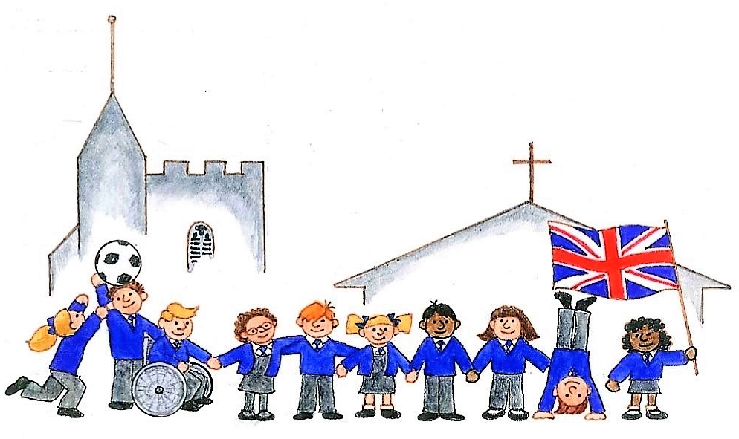
HAGBOURNE CE PRIMARY SCHOOL
Main Road, East Hagbourne, Didcot, Oxon, OX11 9LR
Tel: 01235 813367 Email: office.3249@hagbourne.oxon.sch.uk www.hagbourne.oxon.sch.uk

Monday 3rd November 2025

Dear Parents and Carers,

We hope you and your children enjoyed the half term break. Here is some important general information for this half-term.

MORNING SCHOOL DROP OFF:
The children can be dropped off at school at 8.35am when the side gate is opened and closing at 8.45am. Many children are now independent in putting their own book bag and water bottle in the correct places and can hang their coats on pegs. If you have a quick message about your child, please speak to us at the gate or if you need to speak for longer please see me at the end of school when time is not so limited, or make an appointment.

HOME TIME:
Please make sure that you inform one of the Reception team if someone different and unfamiliar is picking up your child. This applies to your children going on playdates with their friends too.

LOST CLOTHING:
We encourage the children to put their jumpers in their trays. We work hard to teach the children to look after things. Please name everything! Good places to look for lost items include the office or on the shelf in the bike shed. If it is named, it is usually returned if someone accidentally takes it home.

OUTDOOR LEARNING:
We spend a lot of time outdoors in all weathers. Please make sure your child has a warm, waterproof coat. Forest School activities will take place on Tuesday afternoons. The children need to come to school dressed in old home clothes every Tuesday and to bring in NAMED wellies. Please ensure that your child also has indoor shoes that they can put on and do up themselves on Tuesdays.

PE will start this week.The children need to bring in their PE kit to school which may be kept on their pegs for the rest of term. It is an important part of the EYFS curriculum for the children to be able to dress independently, therefore please continue to encourage/support your child at home.

THINGS FROM HOME:
We discourage children from bringing in toys (including soft toys). We find the children often lose the things they bring in and then this causes upset. If they wish to bring something in for Show and Tell on Mondays they will need to keep it safely in their book bag.

WATER: Children are encouraged to bring in a named water bottle each day, this should be filled with water only.

PHONICS, READING AND WRITING:
Children take part in various reading activities and a phonics session daily. Prior to reading, we encourage the children to practice the sounds in the book to reinforce and prepare them for reading. Please continue to support your child in reading each day and feel free to comment in the reading diary. Reading at home is such an important part of your child’s education.

ILLNESS:
This is the term of coughs, colds, sickness and diarrhoea, temperatures, throat and ear infections! The children are tired and will be susceptible to catching things. Please ensure that they are better when they return to school, 48 hours after sickness and diarrhoea. This will prevent further spread of all these viruses and infections. Please contact school before 9am to inform us of absence.

TOPIC:
This term we will be learning about ‘Traditional Tales’ topic, please see the attached topic overview. Very soon, we will be learning songs for our Christmas Nativity play which will take place on Wednesday 10th December at 9.30am.

Here’s to another fantastic term!
Many thanks,
The Reception Team

