Maths  - We will be using different resources to help our understanding of Fractions:  - recognise, find, name and write fractions 1/3, 1/4, 2/4 and 3/4 of a length, shape, set of objects or quantity  - write simple fractions, for example 1/2 of 6 = 3 and recognise the equivalence of 2/4 and 1/2.  - Measurement:  - compare and order lengths, mass, volume/capacity and record the results using >, < and =  - compare and sequence intervals of time, tell and write the time to five minutes, including quarter past/to the hour  - know the number of minutes in an hour and the number of hours in a day.  RSHE  During our RSHE lessons, we will be focusing and discussing:  - Keeping myself safe  - How to express ourselves and our opinions respectfully  - Feeling safe in our environment. | Science  Plant growth - Investigating seeds, bulbs and plants and recognising the conditions required for germination and healthy plant growth. | English  Writing  - In Writing this term, we will be focusing on information writing.  Spelling / Phonics  - KS1 word list  - Revisiting Phase 5 graphemes  - Common homophones  - Different suffixes (-ing, -ed, -es, -s, -ful , -less, -ly)  - Possessive apostrophes | Geography  We will be learning about what life is like by the coast. We will be locating the seas and oceans surrounding the UK, understanding the physical features of a coast and investigate how coasts are used by humans.  Computing  - Using the chromebooks and Ipads to delve into the world of computer programming and coding using programmes like ScratchJR and Microsoft MakeCode.  Physical Education  - Swimming  - Rounders  Art  In our Art unit, we will be creating Sculpture and 3D Clay houses.  Music  In our music session this term, our focus is on rhythm and harmony using the song Rockpool rock.
Year 2 - Term 5
Topic Web - Our wonderful world!
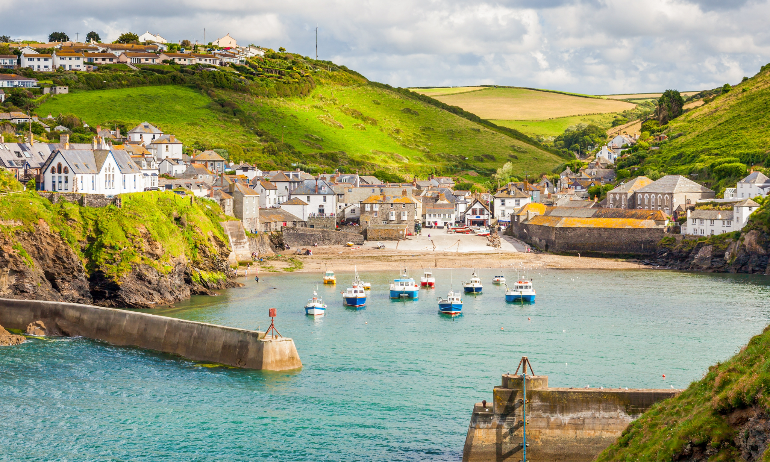
RE
Our big question:
- Do we need shared special places?
  - We will be delving into the religion of Judaism and how they use their place of worship.
- Our Christianity focus is on the Gospel.

