HAGBOURNE C of E PRIMARY SCHOOL
Main Road, East Hagbourne, Didcot, Oxon, OX11 9LR
Tel: 01235 813367 Email: office.3249@hagbourne.oxon.sch.uk www.hagbourne.oxon.sch.uk
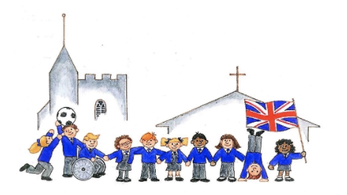

‘Be the best you can be’
CARE - COURAGE - RESPECT - RESPONSIBILITY

Tuesday 6th January 2026
Dear Parents and Carers,

Happy New Year! We hope you and your family had a relaxing Christmas break and would like to thank you for all the kind cards, messages and presents at the end of last term.

Our topic this term is ‘Our Planet’. It is a geography focus unit where we will be trying to answer the question, Why is our world wonderful?.

If you would like to know more information, please click here Year 2 Term 3 - Our Planet.

General
- P.E is on Tuesday (Outdoor - Orienteering) and Friday (Indoor - Dance)
- Reading journals will be checked regularly and books will be changed on a Friday.
- All clothes and personal belongings should be clearly named please, with an indelible pen or a label.

Please continue to hear your child read at home. Books will be changed on a Friday and we expect the children to read the same book at least 4 times to develop fluency and improve their orthographic map.

As part of their Christmas present, we adopted a turtle and the class named it Shelly. Shelly will come home with your child for 3-4 days along with a book for them to write, draw or add photos of their mini adventures with the toy. We will be picking out 2 children’s names every week.
We have had a lovely start to year 2 and we are looking forward to starting our new topic.
I hope that this letter covers most of the key questions you may have, however if any other worries or concerns should arise, please don’t hesitate to send me an email or catch me on the door.

Many thanks,
Miss Hawlor, Mrs Tyler and Mrs Sutton
Year 2 Class Teacher and Team.

Spring Term: Monday 5th January to Friday 27th March
INSET day: Monday 5th January
Half Term Holiday: Monday 16th February to Friday 20th February
Easter Holiday: Monday 30th March to Friday 10th April

