Maths  Multiplication and division B  - recall and use multiplication and division facts for the 3, 4 and 8 multiplication tables  - write and calculate mathematical statements for multiplication and division; including two-digit numbers times one-digit numbers  - solve problems, including missing number, positive integer scaling and correspondence problems.  Length and Perimeter  - Understanding and comparing millimetres, centimetres, metres and kilometres.  - Adding and subtracting lengths.  - Understand how to calculate perimeter. | Science  Rocks  - Revision of Rock types and identification from the Geography term 1 topic  Fossils  - Museum Fossil box. Think like archaeologists and examine fossil artefacts. Understand what fossils are and explore them. | English - a range of whole class texts  Writing  - Complete sentences - focus on accuracy  - Paragraphs  - Expanded noun phrases for description  - Fronted adverbials  Spellings  - Prefixes - ‘sub’, ‘tele’, ‘super’, ‘auto’  - Suffixes ’less’ and ‘ly’  - Rare GPCs - The /f/ sounds spelt ‘ch’  - The /k/ sound spelt ‘ch’  Reading  - Individual readers  - Whole class reading  - Weekly Reading Record Check | Geography  - Lesson 1: What is climate?  To understand the position and significance of lines of latitude.  - Lesson 2: Where is Antarctica?  To describe the location and physical features of Antarctica.  - Lesson 3: Who lives in Antarctica?  To describe the human features of Antarctica.  - Lesson 4: Who was Shackleton?  To use four-figure grid references to plot Shackleton’s route to Antarctica.  - Lesson 5: Can we plan an expedition around school?  To plan a simple route on a map using compass points.  - Lesson 6: How did our expedition go?  To follow instructions involving compass points and map a simple route.
Music:  - Playing the keyboard/percussion  - Building keyboard/percussion skills through simple steps  - Weekly sessions to develop an understanding of the use of keyboard/percussion | Term 3  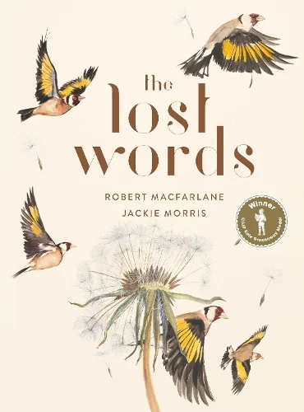  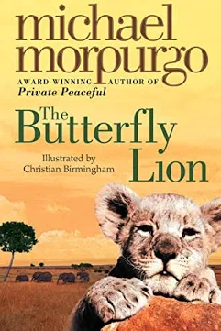  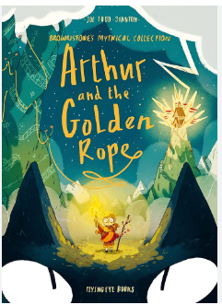 |  | PSHE  - Goal making for the new year  - Friendships  - Rights of the child and responsibilities
PE  - Dance - Friday (indoors)  - Tennis - Wednesday (outdoors) |  |  | French  - French playground games - numbers and age
Art  - Think like an artist - focus on pencil skills and botanical drawing  - DT -Cooking and Nutrition - Eating Seasonally | Computing  - Computing systems and networks 3: Journey inside a computer  Pupils will be able to:  - Recognise inputs and outputs and that the computer sends and receives information.  - Explain that the parts of a laptop work together and the purpose of each part.  - Explain what an algorithm is. |  | RE  - Kingdom of God - A study of the people and concepts surrounding the Kingdom of God and how Jesus and his apostles spread the word of Christianity  - Is a Hindu child free to choose how they live?

