Maths  - Addition and subtraction work - using 3 digit numbers mentally and using efficient written methods  - Multiplication and division.  - Recall and use multiplication and division facts for the 3, 4 and 8 multiplication tables  - Write and calculate mathematical statements for multiplication and division; including two-digit numbers times one-digit numbers  - solve problems, including missing number, positive integer scaling and correspondence problems. | Science  Forces and Magnets  - Children will be exploring different forces and describing the relationship between friction and the roughness of a surface.  - They will investigate magnets in a range of ways including predicting attraction and repulsion between like and opposite poles, identifying examples of magnetic and non-magnetic materials and their differing strengths.  - Children working scientifically will be able to use evidence to support conclusions and identify the variables to change, measure and control. | Music  Nao chariya de & Mingulay boat song  Learn, sing and compare different folk songs.  Find out about symmetry in music  Continue to develop keyboard skills |  | English  Writing  - Write character descriptions.  - Write in-role as a step sister.  - Write a different ending.  - Expressing time, place and cause using conjunctions, adverbs or prepositions  - Introducing speech punctuation  Spellings  - Year 3 - 4 Common exception words, contractions and homophones  Reading  - Class books - history link  - Stone Age Boy  - Stone Age Beasts
Art  - Exploring prehistoric art  - Charcoal animals  - Prehistoric palette  - Painting on the cave wall  - Hands on a cave wall | 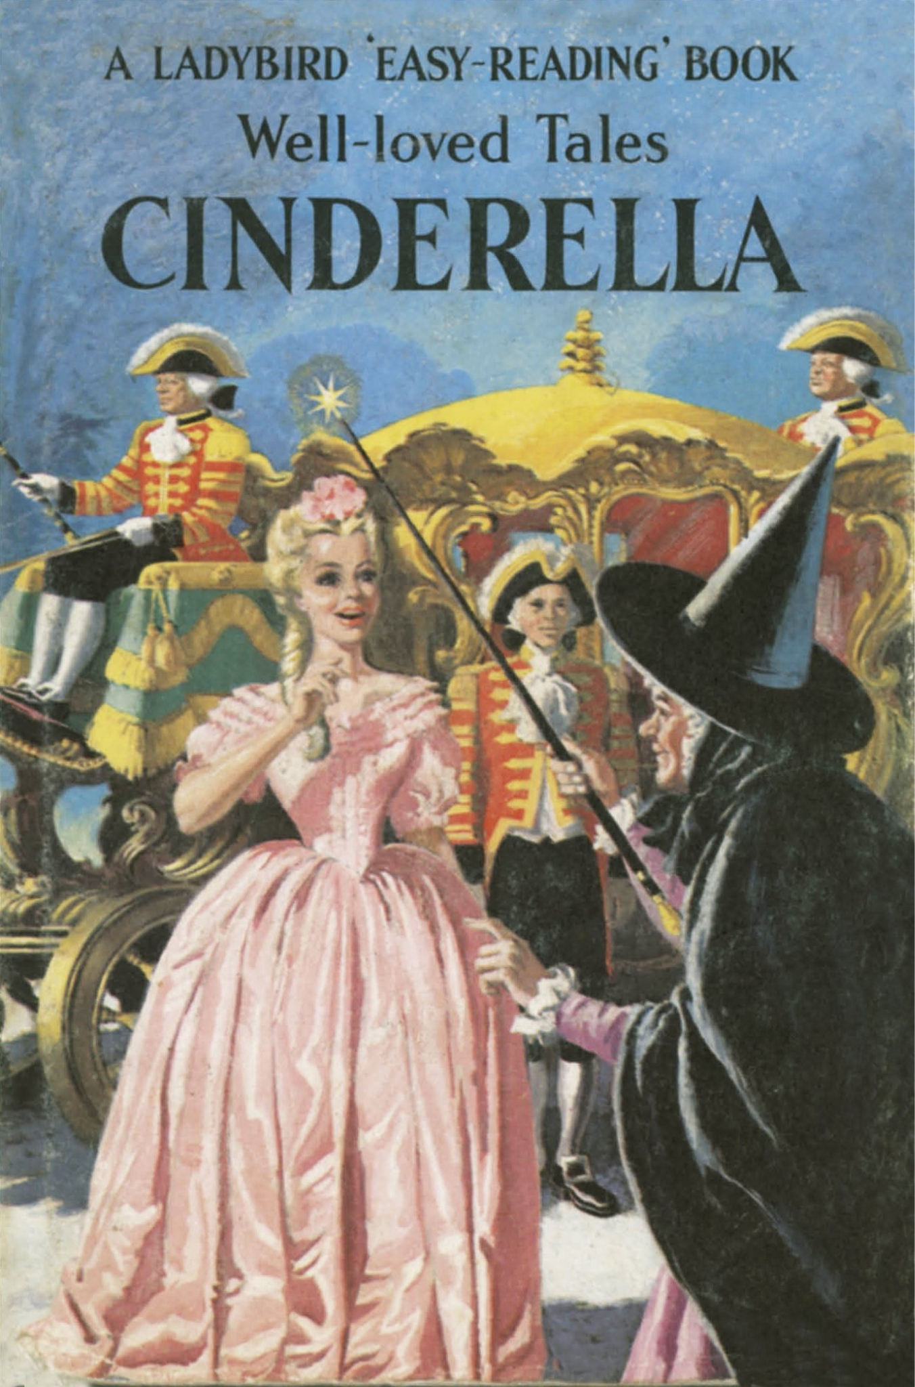  Year 3 - Term 2 - Topic Web  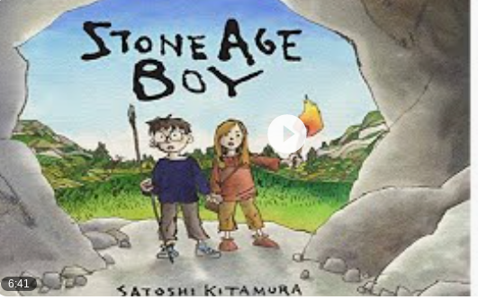 |  |  | History  Would you rather live in the Stone age or the Bronze age?  We will be looking at early civilization through a range of questions:  - How long ago did the Prehistoric man live?  - What does Skara Brae tell us about life in the Stone Age?  - Who was the Amesbury Archer?  - What changes took place in how people found food during the periods?  - True or False, in the Bronze Age people had the same beliefs as in the Stone Age?  We will have a Stone Age - Bronze Age workshop and be answering our main topic question.
RE

- Is light a good symbol for celebration
- Incarnation - Understanding Christianity
- What is the Trinity?
- What is incarnation - God came to Earth at Christmas in the form of Jesus
 | Computing  Programming Scratch  - Identify Scratch as a coding application and explore its different code blocks.  - Make predictions about what code blocks will do and test these ideas.  - Create a simple animation by combining motion, speech and wait blocks.  - Plan how to remix an existing animation by choosing which parts to change.  - Alter and remix code to create a new version of an animation.  - Test and debug animations to fix problems and improve the code and reflect on the changes made, explaining what worked well and what could be improved. |  | RSHE  - Scarf lessons - Valuing Differences  - Value focus - Care  - KiVa program - anti bullying - Getting to know each other
PE  - Tag Rugby - Thursdays - Outdoors  - Gymnastics - Fridays - Indoors |  |  |  | French  - Colours - recognise and name  - Shapes - describe shapes  - The French artist Matisse and cognates  - Follow instructions in French

