Science - Movement and Nutrition  The Skeleton and joints:  - Name the functions of the skeleton and the muscles  - Know vertebrates, invertebrates, endoskeleton and exoskeleton  - Name key bones from animal skeletons  - Look at nutrition for survival and health  - Look at a nutritionally balanced meal. | English  Writing - Handwriting focus - Fiction writing based around the text - The Tree and the River - Orally rehearse sentences to describe change.  The Boy who Grew Dragons - Write in character and how to keep a pet.  Poetry - The Kingfisher  Reading - Guided reading - whole class use of non-fiction book - The boy who grew dragons  Grammar - accurate simple punctuation, full-stops, capital letters, expanded noun phrases, sentences for making sense, finger spaces, accurate use of ‘a’ and ‘an’. | Maths  Number - place value: addition and subtraction  Recognising, representing, ordering, comparing and partitioning numbers to 1000. Strategies for efficient addition and subtraction  Times Tables practice daily and for homework. | Topic - Geography -  Volcanoes and Earthquakes  Our learning will include:  - How to use an Atlas including the index  - Identifying Mountain ranges  - How mountains, volcanoes and earthquakes are formed  - The benefits of living near a volcano or not.
R.E. - from Oxfordshire Agreed Syllabus  Christianity  - The Creation story  - The Fall - story of Adam and Eve  - Choices of a Jewish child | Year 3 Term 1 - Topic Web  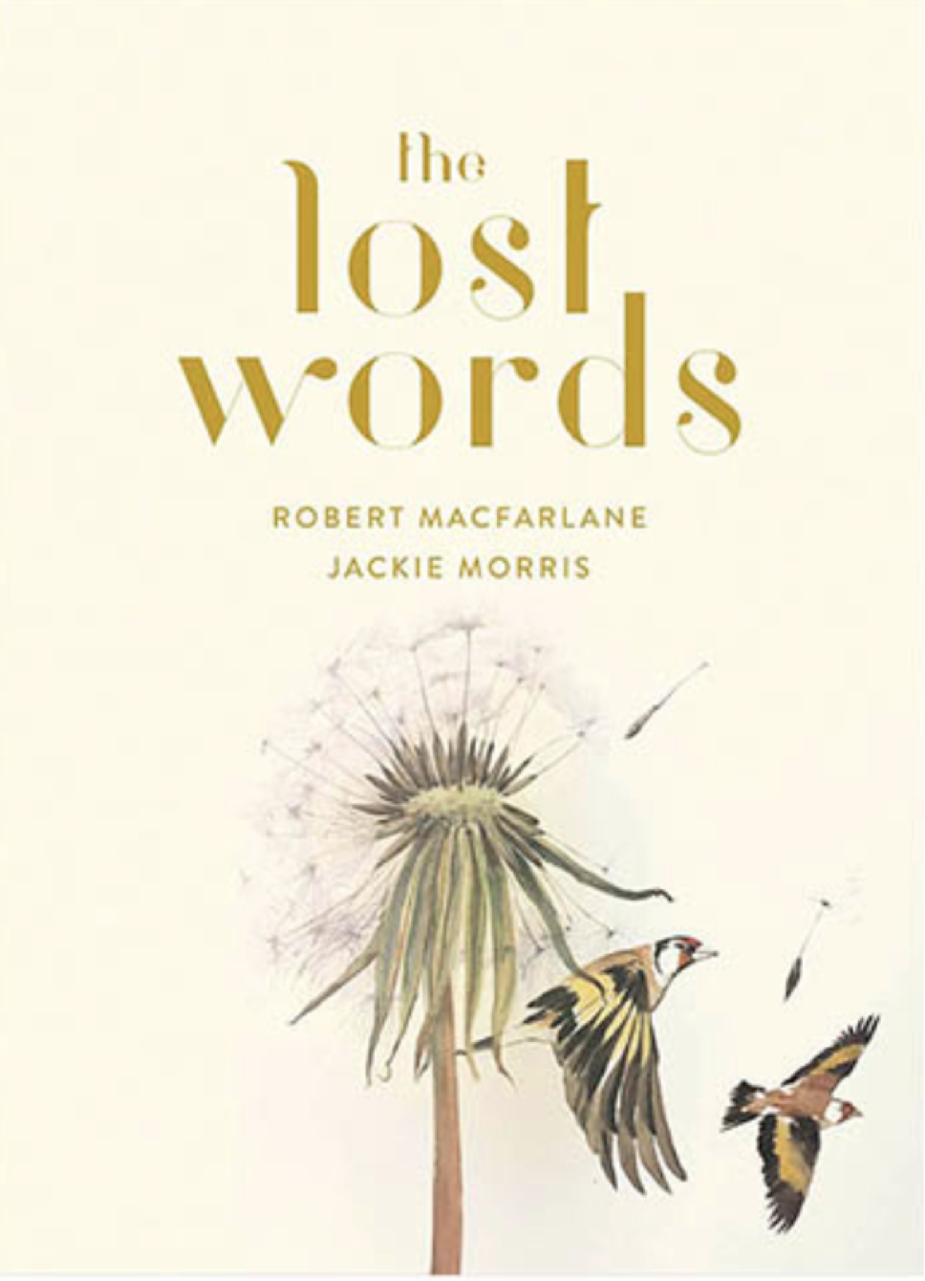  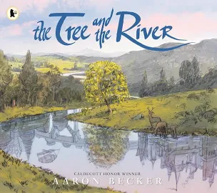  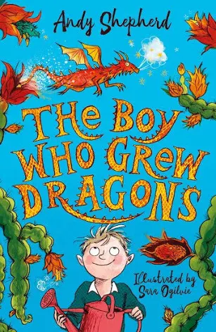 |  | Computing  - Computing systems and networks - An introduction  - Internet Safety  - Use of Chromebooks and iPads for research
P.E.  - Basketball - Wednesday  - Swimming - Friday (Starting Friday 13th September) |  |  | Music  - Exploring different genres of songs. Singing in unison. Focus on 3 songs.
Spelling  - Spellings from the statutory list for Year 3 & 4  - Prefixes, suffixes, recap year 2 spellings  - Daily practice tasks | D&T - Digital wearable technology  Children will design a piece of wearable digital technology that can keep a child safe when walking home in the dark.  They will design a micro:bit program to flash and be visual. | French  - Greetings and feelings | PSHE  - Goal setting - individual/teams  - Teamwork/ getting to know each other  - Relationships and me  - Practise makes progress

