HAGBOURNE C of E PRIMARY SCHOOL
Main Road, East Hagbourne, Didcot, Oxon, OX11 9LR
Tel: 01235 813367 Email: office.3249@hagbourne.oxon.sch.uk www.hagbourne.oxon.sch.uk
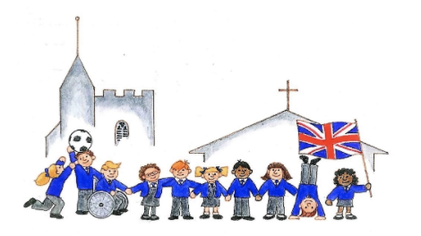

‘Be The Best You Can Be”
CARE - COURAGE - RESPECT - RESPONSIBILITY
6th January 2026
Dear Parents and Carers,

Happy New Year! We hope you and your family had a relaxing Christmas break and we would like to thank you again for all the kind cards, messages and presents at the end of last term.

English
In English, we will continue our focus on sentence structure, handwriting and descriptive language. We will continue with our learning about building descriptions using expanded noun and adverbial phrases, and begin to organise our writing using paragraphs to show a change of time, place or subject. The aim is to ensure that the children are secure in their knowledge of sentence structure and composition before moving on to more advanced aspects of writing.

Maths
In maths, we will continue to revise the 2, 3, 4, 5 and 10 Times tables. We will move onto learning the 8 Times Tables and learning various written methods for multiplying and dividing 2 digit numbers. The aim is for the children to know their table facts with automaticity (within 6 seconds) rather than counting up the multiples. Please ensure children are practising Times tables using the online platform ‘Times Tables Rockstars’ or Hit the Button. All children should know their login details.

Reading
As before, the children will continue to have books changed on a Thursday. It is important that they read at home every day to ensure that they are making optimal progress.

General
- P.E is on Wednesdays (Tennis - outside) and Fridays (Dance - inside). Children with pierced ears will either need to be able to take out their own earrings, put plasters over their ears or ideally not wear earrings to school that day.
- On Monday afternoons, we will be splitting the class into 2 groups for Forest school and DT – Cooking Seasonal Food. Please see the attached group list with dates. There will be one whole class session in the last week.
- We have an Oxfordshire Museum Fossil Box booked for the term where children will be able to handle and explore real fossils and exceptional replicas.

Homework
Spellings and written maths homework will continue to be set weekly on Fridays from the homework book and will link to the class learning. Times Tables will also be sent out each week for children to practice.

I hope that this letter covers most of the key questions you may have, however if any worries or concerns should arise, please don’t hesitate to send an email.

Many thanks,
Mrs Head and Mrs Lewis
Year 3 Team

