HAGBOURNE C of E PRIMARY SCHOOL
Main Road, East Hagbourne, Didcot, Oxon, OX11 9LR
Tel: 01235 813367 Email: office.3249@hagbourne.oxon.sch.uk www.hagbourne.oxon.sch.uk
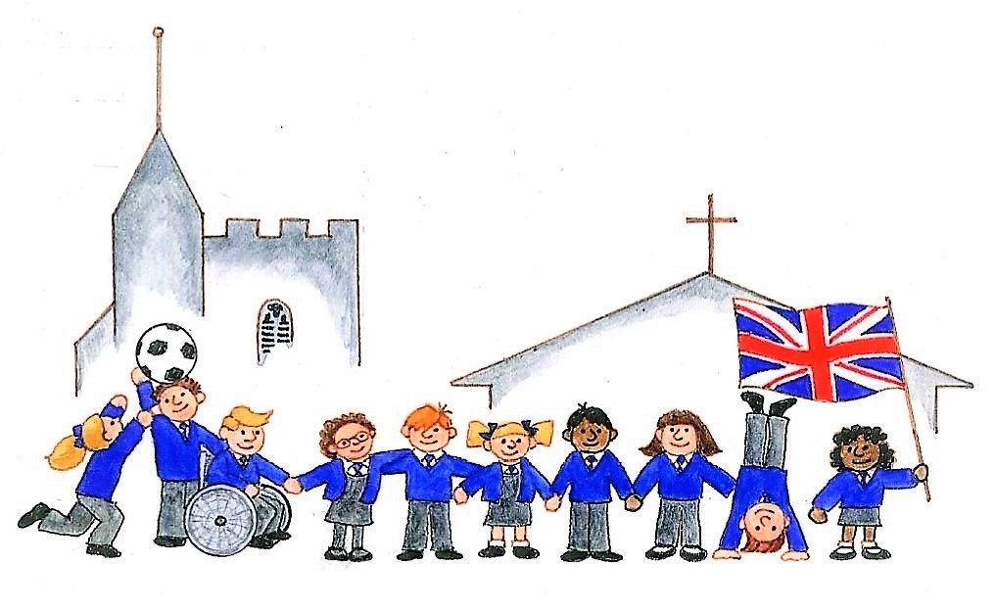
‘Be the best you can be’
CARE - COURAGE - RESPECT - RESPONSIBILITY

Monday 3rd November 2025
Dear Families,

Welcome back! We hope you have had an enjoyable half-term break.

TOPIC: History - Would you prefer to live in the Stone Age or the Bronze Age?
This term, our topic is history - Stone Age to Bronze Age. We will be investigating how we know about early civilisations and how reliable our knowledge is based on archaeological evidence. We will compare how people lived and survived during the Stone Age through to the Bronze Age. This will include how living, farming, tools, settlements and beliefs changed over this period. The Oxfordshire Heritage Museum workshop about the lives of the Stone Age and Bronze Age people will be coming to bring History to life on the 18th November in class. A letter with details and costs for this will be sent out today also.

Mathematics
This term, we will be continuing our addition and subtraction learning, including the use of number lines, part-whole models, use of number bonds, complements to 100 and formal written methods. We will begin working on multiplication and division - mental methods and formal written methods. There will be regular opportunities for the children to reason about maths and to use their mathematical skills to solve simple problems. We will revisit the 3 times-table regularly and continue to work through the 2, 5 and 10 times-tables. We will start learning our 4 times table with regular table practice and the 8 times table will be introduced.

English
This term we will be reading class books which are linked to our topic - including Stone Age Boy. We will also be looking at different versions of the Folk Tale - Cinderella - which will support our writing for the first three weeks. The main focus for writing will be writing character descriptions.

Homework
Thank you for supporting your children so far this year in their homework. It makes a huge difference. Please continue hearing your child read every day if possible. 4 sessions noted in reading records are awarded house points. Spellings and Maths homework will continue weekly.

PE days

PE will be on Thursday (outdoor tag rugby) and Fridays (indoor gymnastics). Please make sure your child is wearing their PE kits to school on these days. This includes ensuring long hair is tied back and ear rings are removed - thank you.

As always, please catch us on the gate with any small issues or questions but if you have any bigger questions or queries please send an email or contact the office to arrange a telephone call.

Thank you for your continued support,

Mrs Head and Mrs Lewis
Year 3 Team

