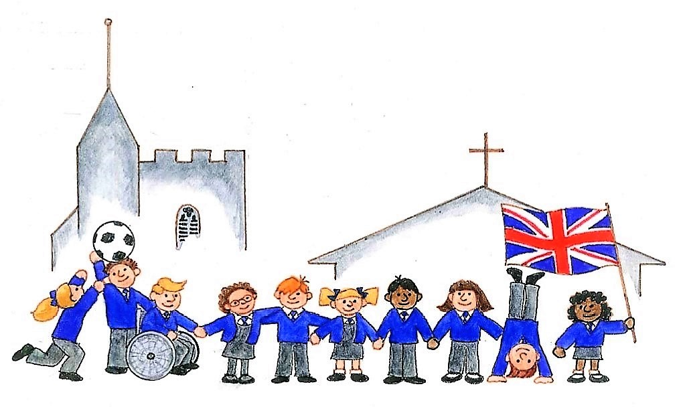
HAGBOURNE CE PRIMARY SCHOOL
Main Road, East Hagbourne, Didcot, Oxon, OX11 9LR
Tel: 01235 813367 Email: office.3249@hagbourne.oxon.sch.uk www.hagbourne.oxon.sch.uk

Wednesday, 3rd September 2025

Dear Families,

Welcome back! We hope you have had a wonderful Summer holiday! Here is some general information about Year 3, and more specific information about the topics that we will be learning about in Term 1:

Topic and Science: Volcanoes and Skeletons
This term, our topic has a geography focus. We will be looking at Atlases and using ICT to research famous Mountain ranges and volcanoes of the World. We will find out how volcanoes and earthquakes are formed and how they affect the local people and natural world. Science will be an exploration of the human skeleton and skeletons of a range of animals - including their function and make-up.

English and Maths
Our English lessons will include a focus on handwriting and accuracy in sentence writing, punctuation and structure, as well as developing interest in fiction description-writing using expanded noun phrases. Our class books are ‘The boy who Grew Dragons’ and the ‘The River and the Tree’’. We will also look at the poetry writing of ‘The Kingfisher’ from ‘The Lost Words’. A central aim will be to ensure the children are confident in writing well-structured sentences in neat cursive writing. Each day, we have a spelling focus along with either a reading session or handwriting lesson.

This term, mathematics will focus on place value. This will involve recognising, representing, writing, saying, ordering, comparing and partitioning numbers to 1000. Strategies for Addition and Subtraction and mental addition/subtraction will form the focus of the second part of Term 1.

Homework
Please can the children continue to read daily and fill in their reading records. Reading regularly forms the building blocks of everything they need to learn in school and for lifelong learning. Here is a list of popular books that year 3 children may like to read independently -
https://www.booksfortopics.com/booklists/recommended-reads/year-3/

Children also benefit from being read to. A book rich in language read by a confident reader is vital for comprehension and vocabulary understanding. Try some of these - https://www.thereaderteacher.com/year3 .

Alongside reading, this term we will start to send home spellings and a maths sheet each week. These will consolidate what we have been learning in class recently or revise previous learning. The sheets will be sent home on Friday and should be returned by the following Friday. Please make any pertinent notes to us on the sheet. A reasonable time of 15-20 minutes maximum is expected for this homework. They do not have to do more than this time limit. As the year progresses we will send times tables practise sheets. The children also have access to Times Tables Rockstars which they can access at home too.

Lexia Reading Programme
The children can continue to work through the Lexia reading programme independently at home.

General Info
- Wednesday – PE kit to be worn - Basketball
- Friday – PE kit to be worn - swimming (please ensure your child has their named swimming kit including, towel, costume, goggles and hat in a bag) - Swimming bags required from Friday 13th September.
- Friday - homework due in
- The Government fruit and vegetable snack scheme only runs in Key Stage 1. Now your children are in Year 3, they are in Key Stage 2. If your child would like a snack, please provide them with a healthy snack such as a piece of fruit or ‘healthy’ cereal bar each day (not chocolate or crisps). They should also have their water bottle in school every day - this should only contain water.

If you have any questions or queries please send an email or contact the school to arrange a telephone call or meeting.

Thank you!

Year 3 Team
Mrs Head (Monday - Thursday) and Mrs Lewis (Fridays)

Email for Mrs Head:- vhead@hagbourne.oxon.sch.uk
Email for Mrs Lewis:- sjlewis@hagbourne.oxon.sch.uk

